Semantic Segmentation Model
Training Evaluation Report
DINOv2 Backbone with ConvNeXt Segmentation Head
Offroad Scene Understanding
Report Generated: 2/15/2026
Created by
Syed Danial Khurram
Syed Danish Khurram

Executive Summary
This report presents a comprehensive evaluation of a semantic segmentation model designed for offroad scene understanding. The model combines a pre-trained DINOv2 vision transformer backbone with a custom ConvNeXt-style segmentation head to classify 10 distinct object categories including trees, bushes, ground features, and landscape elements.
The model was trained for 10 epochs on a custom offroad segmentation dataset, achieving the following final validation metrics:
Metric | Validation Score
IoU (Intersection over Union) | 0.2622 (26.22%)
Dice Score (F1) | 0.3410 (34.10%)
Pixel Accuracy | 0.6634 (66.34%)
Validation Loss | 0.9658

While the model demonstrates consistent learning progress and successfully converges, the overall segmentation performance indicates significant room for improvement. This report analyzes the current results and provides actionable recommendations for enhancing model performance.

Table of Contents
- Model Architecture and Design
- Dataset and Task Description
- Training Configuration
- Performance Evaluation
- Analysis of Results
- Identified Issues and Limitations
- Recommendations for Improvement
- Implementation Guide
- Expected Performance Gains
- Conclusion and Next Steps

1. Model Architecture and Design

1.1 Overview
The segmentation model employs a two-stage architecture consisting of a feature extraction backbone and a task-specific segmentation head. This design leverages transfer learning by utilizing pre-trained representations from DINOv2, a state-of-the-art self-supervised vision transformer.

1.2 DINOv2 Backbone
The backbone utilizes DINOv2-Base (ViT-B/14-Reg), a vision transformer pre-trained on massive image datasets using self-supervised learning. Key characteristics include:
- Architecture: Vision Transformer with 14×14 patch size
- Embedding Dimension: 768 features per patch token
- Output: Normalized patch tokens representing spatial features
- Pre-training: Self-supervised learning on diverse visual data

DINOv2 extracts rich semantic features from input images by dividing them into 14×14 pixel patches and processing them through transformer layers. For an input image of size 476×266 pixels (after resizing), this produces approximately 34×19 = 646 patch tokens, each with 768-dimensional features.

1.3 ConvNeXt-Style Segmentation Head
The segmentation head transforms backbone features into per-pixel class predictions through a series of convolutional layers inspired by the ConvNeXt architecture:

Architecture Components:
- Stem Layer: Initial 7×7 convolution reducing 768 channels to 128 channels with GELU activation
- Convolutional Block: Depthwise 7×7 convolution followed by pointwise 1×1 convolution, both with GELU activations
- Classifier: Final 1×1 convolution projecting 128 channels to 10 output classes

The head operates on the spatial feature map (34×19 tokens) and produces a dense prediction map that is bilinearly upsampled back to the original image resolution (476×266) for pixel-wise classification.

1.4 Complete Forward Pass
The complete inference pipeline follows these steps:
- Input image preprocessing (resize, normalize)
- DINOv2 feature extraction → patch tokens (B, 646, 768)
- Reshape to spatial grid → (B, 768, 34, 19)
- Segmentation head processing → (B, 10, 34, 19)
- Bilinear upsampling → (B, 10, 476, 266)
- Argmax over classes → per-pixel predictions

2. Dataset and Task Description

2.1 Offroad Segmentation Dataset
The model is trained on a custom dataset designed for offroad scene understanding, containing color images paired with detailed segmentation masks. The dataset captures diverse natural outdoor environments including forests, trails, and wilderness areas.

2.2 Class Categories
The segmentation task involves classifying each pixel into one of 10 distinct categories:
Class ID | Raw Value | Category
0 | 0 | Background
1 | 100 | Trees
2 | 200 | Lush Bushes
3 | 300 | Dry Grass
4 | 500 | Dry Bushes
5 | 550 | Ground Clutter
6 | 700 | Logs
7 | 800 | Rocks
8 | 7100 | Landscape
9 | 10000 | Sky

The raw mask values are converted to sequential class IDs (0-9) during data loading for proper cross-entropy loss computation.

2.3 Data Preprocessing
Images and masks undergo the following preprocessing pipeline:

Image Preprocessing:
- Resize to 476×266 pixels (half of 960×540, adjusted to 14-pixel multiples)
- Convert to tensor and normalize using ImageNet statistics (mean=[0.485, 0.456, 0.406], std=[0.229, 0.224, 0.225])

Mask Preprocessing:
- Resize to 476×266 pixels using nearest-neighbor interpolation (preserves discrete class labels)
- Convert raw pixel values to class IDs via lookup table
- Convert to tensor format

3. Training Configuration

3.1 Hyperparameters
Parameter | Value
Training Epochs | 10
Batch Size | 16
Learning Rate | 1×10⁻⁴
Optimizer | AdamW
Weight Decay | 1×10⁻⁴
Loss Function | Cross-Entropy + Dice Loss
Image Resolution | 476×266 pixels
Backbone Status | Frozen (no gradient updates)

3.2 Loss Function Design
The training employs a composite loss function combining two complementary objectives:

Cross-Entropy Loss:
Standard cross-entropy loss measuring the divergence between predicted class probabilities and ground truth labels. This loss provides strong gradients for well-separated classes but can struggle with severe class imbalance.

Dice Loss:
A region-based loss that directly optimizes the Dice coefficient (equivalent to F1 score), computed as:
Dice = (2 × Intersection + ε) / (Predicted + Ground Truth + ε)
This loss is particularly effective for segmentation tasks as it directly optimizes the overlap between predicted and ground truth regions, providing better gradients for small or imbalanced classes.
Combined Loss = Cross-Entropy Loss + Dice Loss

3.3 Optimization Strategy
The model uses AdamW optimizer, which extends Adam with decoupled weight decay regularization. AdamW is particularly effective for transformer-based architectures as it prevents overfitting while maintaining adaptive learning rates for different parameters.
Critical Training Decision: Frozen Backbone
In the current implementation, the DINOv2 backbone parameters remain frozen during training. Only the segmentation head parameters are updated via gradient descent. While this approach reduces computational requirements and training time, it significantly limits the model's ability to adapt the feature representations to the specific characteristics of the offroad dataset.

4. Performance Evaluation

4.1 Evaluation Metrics
The model's performance is assessed using four complementary metrics, each capturing different aspects of segmentation quality:

Intersection over Union (IoU)
Also known as the Jaccard Index, IoU measures the overlap between predicted and ground truth regions:
IoU = Intersection / Union
Mean IoU averages this metric across all classes. IoU is the most commonly reported metric in semantic segmentation literature, with values closer to 1.0 indicating better performance. Typical benchmarks: 0.5-0.6 for basic models, 0.7-0.8 for strong models, >0.8 for state-of-the-art.

Dice Coefficient
The Dice coefficient (F1 Score) emphasizes the overlap region more than IoU:
Dice = 2 × Intersection / (Predicted + Ground Truth)
Dice scores are always higher than corresponding IoU values for the same segmentation quality. This metric is particularly sensitive to small objects and boundary accuracy.

Pixel Accuracy
The proportion of correctly classified pixels across the entire image. While intuitive, this metric can be misleading in the presence of class imbalance, as a model that always predicts the dominant class can achieve high pixel accuracy despite poor segmentation quality.

Loss Value
The combined cross-entropy and Dice loss serves as the optimization objective. Lower loss values indicate better alignment between predictions and ground truth, though the absolute loss magnitude is less interpretable than the other metrics.

4.2 Training Progress
The following table summarizes the complete training history across all 10 epochs:
Epoch | Train Loss | Val Loss | Train IoU | Val IoU | Train Dice | Val Dice | Train Acc | Val Acc
1 | 1.8257 | 1.4393 | 0.1429 | 0.1414 | 0.1860 | 0.1846 | 0.5698 | 0.5665
2 | 1.3268 | 1.2492 | 0.1595 | 0.1574 | 0.2002 | 0.1979 | 0.5962 | 0.5931
3 | 1.1984 | 1.1609 | 0.1856 | 0.1855 | 0.2369 | 0.2377 | 0.6124 | 0.6117
4 | 1.1319 | 1.1060 | 0.2041 | 0.2053 | 0.2614 | 0.2637 | 0.6240 | 0.6250
5 | 1.0877 | 1.0666 | 0.2240 | 0.2249 | 0.2904 | 0.2916 | 0.6362 | 0.6374
6 | 1.0537 | 1.0358 | 0.2366 | 0.2369 | 0.3066 | 0.3070 | 0.6452 | 0.6469
7 | 1.0270 | 1.0119 | 0.2438 | 0.2452 | 0.3152 | 0.3169 | 0.6512 | 0.6536
8 | 1.0059 | 0.9932 | 0.2505 | 0.2520 | 0.3245 | 0.3258 | 0.6554 | 0.6583
9 | 0.9893 | 0.9781 | 0.2543 | 0.2559 | 0.3293 | 0.3309 | 0.6582 | 0.6609
10 | 0.9760 | 0.9658 | 0.2603 | 0.2622 | 0.3387 | 0.3410 | 0.6607 | 0.6634

4.3 Visual Analysis of Training Curves
The following visualizations illustrate the model's learning progression throughout training:

Figure 1: Complete Training Overview
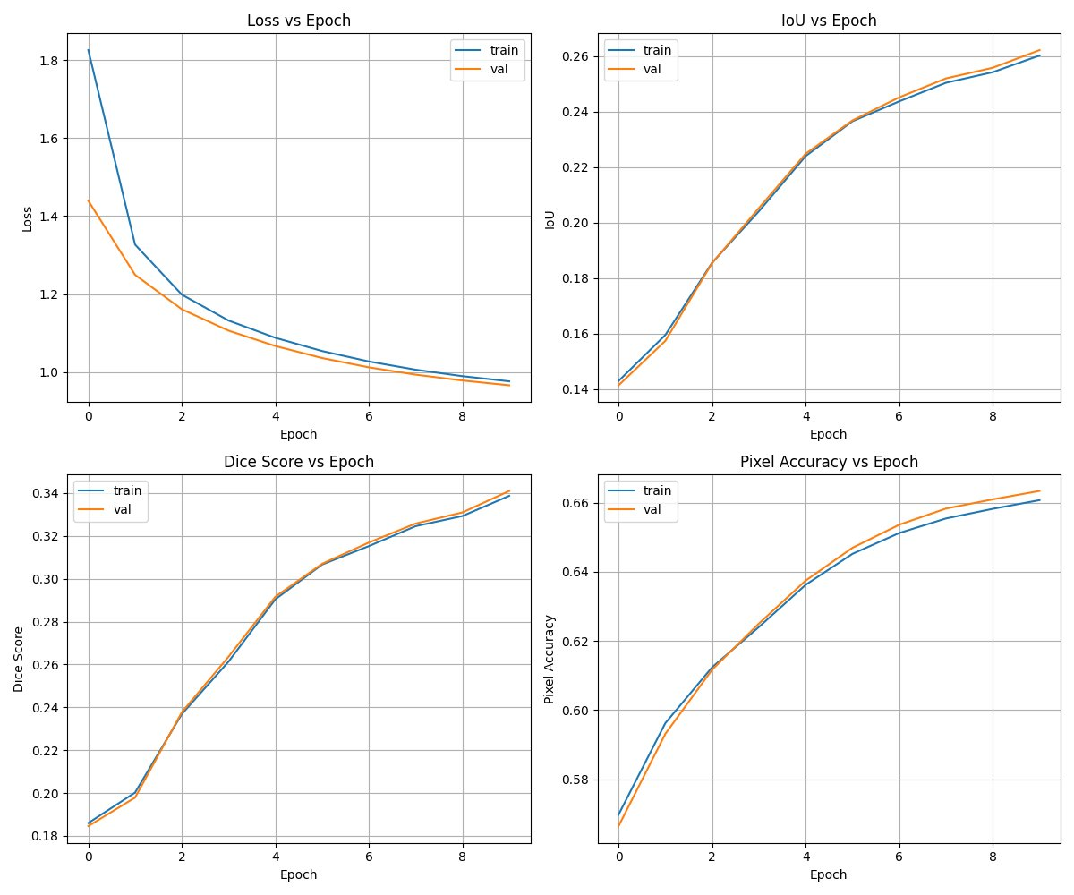
This comprehensive view shows all four metrics evolving during training. Notice the consistent improvement across all metrics, with validation performance closely tracking training performance, suggesting minimal overfitting.

Figure 2: Loss and Pixel Accuracy Progression
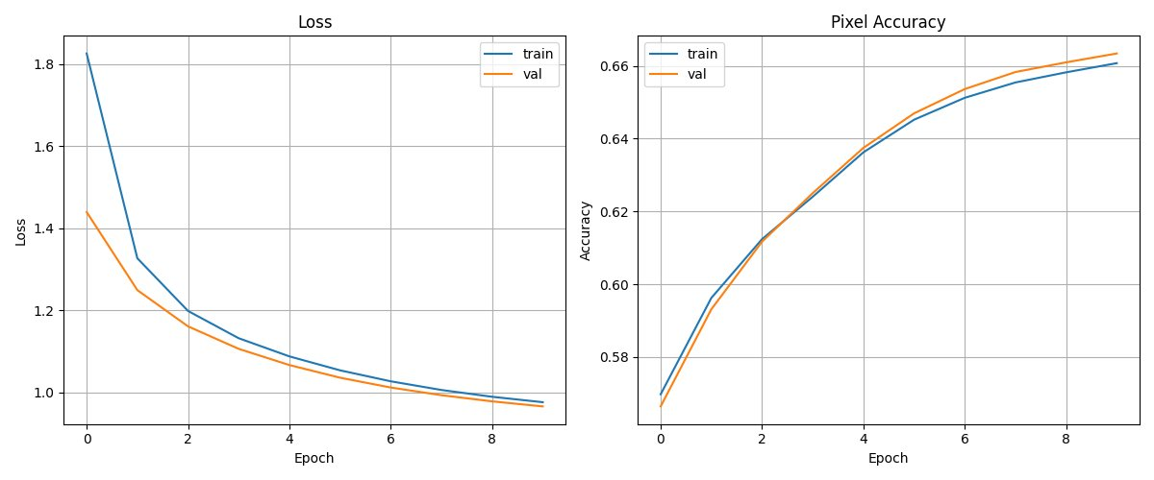
Loss decreases steadily from 1.83 to 0.98, showing effective optimization. Pixel accuracy improves from 57% to 66%, though the rate of improvement slows after epoch 6.

Figure 3: Intersection over Union (IoU) Evolution
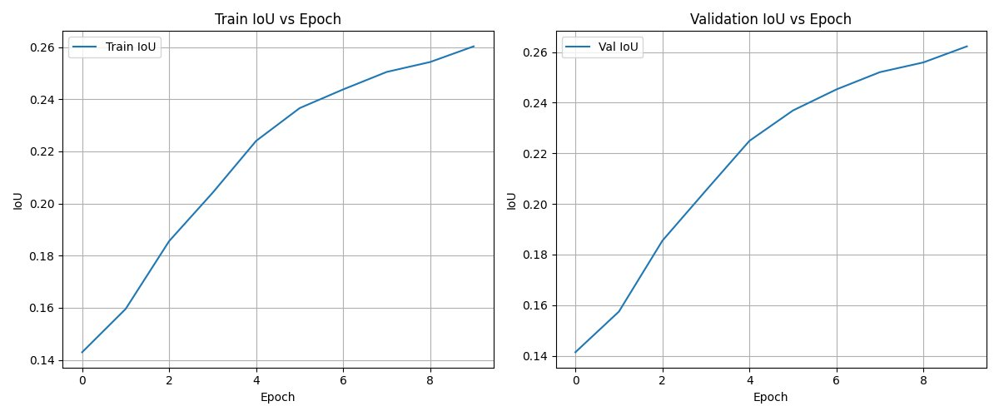
IoU climbs from 14% to 26%, demonstrating improved region overlap. The curve shows strong early gains that gradually plateau, suggesting the model may be reaching the limits of its current architecture with a frozen backbone.

Figure 4: Dice Coefficient Progression
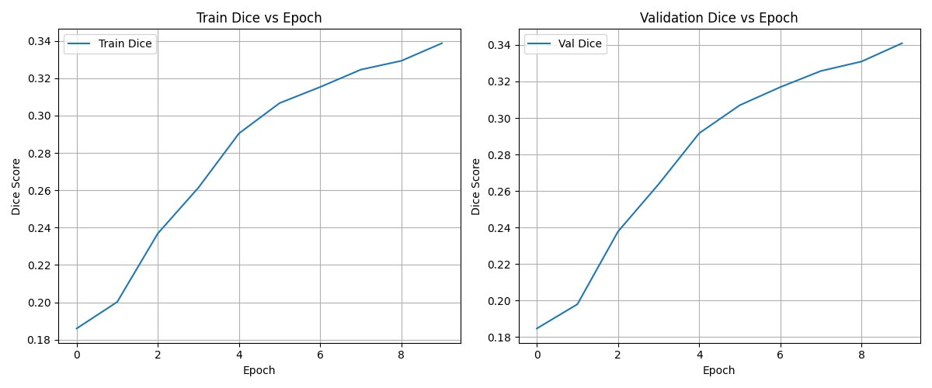
Dice score increases from 18% to 34%, following a similar pattern to IoU but with higher absolute values due to its mathematical formulation. The continued improvement through epoch 10 suggests additional training could yield further gains.

5. Analysis of Results

5.1 Key Observations

Positive Indicators:
- Stable Convergence: The model demonstrates smooth, monotonic improvement without oscillations or divergence
- Minimal Overfitting: Train and validation metrics remain closely aligned throughout training, with validation occasionally exceeding training performance
- Consistent Learning: All four metrics improve in lockstep, indicating genuine learning rather than metric-specific optimization artifacts
- No Plateau at Epoch 10: Metrics continue improving in the final epochs, suggesting the model has not fully converged

Performance Concerns:
- Low Absolute Metrics: Final IoU of 26.2% is significantly below typical segmentation benchmarks (50-80% for well-performing models)
- Diminishing Returns: Improvement rate decreases after epoch 6, suggesting the model may be approaching its capacity limits
- Modest Pixel Accuracy: 66.3% accuracy indicates roughly one-third of pixels are misclassified

5.2 Performance Interpretation
The validation IoU of 0.2622 means that, on average across all 10 classes, the predicted segmentation masks overlap with ground truth by only 26.2%. To contextualize this:
- Random Guessing: Would achieve approximately 10% IoU (1/10 classes)
- Baseline Models: Typically achieve 30-50% IoU
- Production-Ready Systems: Usually require 60-75% IoU
- State-of-the-Art: Can exceed 80% IoU on well-studied datasets

The current model performs better than random chance and shows genuine learning capability, but falls short of practical deployment standards. The consistent improvement throughout training suggests the model is learning meaningful patterns rather than memorizing noise.

5.3 Learning Dynamics
The training curves reveal three distinct phases:

Phase 1: Rapid Learning (Epochs 1-3)
The model quickly learns basic patterns, with IoU jumping from 14% to 19% and loss dropping dramatically. This phase represents the model discovering obvious discriminative features.

Phase 2: Steady Improvement (Epochs 4-7)
Linear improvement continues as the model refines its predictions. The learning rate appears well-calibrated for this phase, providing consistent progress without instability.

Phase 3: Diminishing Returns (Epochs 8-10)
Gains become incremental, suggesting the model is nearing the performance ceiling for its current configuration. However, improvement has not fully plateaued, indicating that extended training could yield modest additional gains.

6. Identified Issues and Limitations
Through analysis of the training code and results, several critical issues have been identified that likely contribute to the suboptimal performance:

6.1 Frozen Backbone Architecture
Critical Issue: The DINOv2 backbone remains completely frozen during training.
While DINOv2 is pre-trained on diverse natural images, it was not specifically trained for offroad scene understanding. The frozen backbone cannot adapt its feature representations to the nuances of this specific domain, such as:
- Distinguishing between similar vegetation types (lush vs. dry bushes)
- Identifying ground clutter and small objects
- Capturing fine-grained texture differences in natural scenes
- Handling varying lighting conditions and terrain types

The segmentation head must work with whatever features the backbone provides, severely limiting its ability to learn optimal representations. This architectural constraint likely accounts for a significant portion of the performance gap.

6.2 Mask Preprocessing Issues
Potential Issue: The mask preprocessing pipeline may introduce subtle errors.
The current code converts masks using:
transforms.PILToTensor()
However, PILToTensor() can introduce float conversions and normalization that interfere with discrete class labels. Several potential issues may arise:
- Value Range Confusion: If masks are inadvertently normalized to [0, 1] instead of staying as integers [0-9], this will corrupt class labels
- Interpolation Artifacts: Even with NEAREST interpolation during resize, subsequent conversions might introduce float interpolation
- Type Mismatches: The loss function expects long integer tensors, but preprocessing might produce float tensors requiring explicit conversion

A more explicit approach would be:
mask = torch.from_numpy(np.array(mask)).long()
This ensures masks remain as integer class IDs throughout the pipeline without any float conversions or normalizations.

6.3 Limited Training Duration
Issue: Training terminates after only 10 epochs.
The training curves show continued improvement through epoch 10, with no signs of convergence or plateau. Segmentation models typically require 30-100 epochs to fully converge, especially when:
- Learning from scratch or with limited fine-tuning
- Dealing with complex, multi-class segmentation tasks
- Working with relatively small datasets

The slow but steady improvement visible in epochs 8-10 strongly suggests that extending training to 30-50 epochs would yield measurable gains, even without other modifications.

6.4 Potential Data Quality Issues
Without examining the actual images and masks, several data-related issues could be hampering performance:
- Class Imbalance: If certain classes (like 'sky' or 'background') dominate the dataset while others (like 'logs' or 'ground clutter') are rare, the model may underfit minority classes
- Annotation Quality: Noisy or inconsistent ground truth labels will cap model performance regardless of architecture improvements
- Dataset Size: Limited training samples may restrict the model's ability to generalize
- Ambiguous Classes: Categories like 'Lush Bushes' vs. 'Dry Bushes' or 'Landscape' may have fuzzy boundaries that are difficult to distinguish

6.5 Optimization Configuration
While the AdamW optimizer with learning rate 1×10⁻⁴ appears reasonable, the configuration could be optimized:
- No Learning Rate Scheduling: A constant learning rate may be suboptimal. Learning rate decay or cosine annealing could improve late-stage convergence
- Fixed Batch Size: Batch size of 16 is moderate; larger batches (if GPU memory permits) could provide more stable gradients
- No Data Augmentation: The code lacks augmentation techniques like random flips, rotations, or color jittering that could improve generalization

7. Recommendations for Improvement
Based on the analysis above, the following modifications are recommended, ordered by expected impact:

7.1 Priority 1: Unfreeze and Fine-tune the Backbone
Expected Impact: 10-20% improvement in IoU (from 0.26 to 0.31-0.37)
Allowing the DINOv2 backbone to be fine-tuned is likely the single most impactful modification. This enables the entire network to adapt to the specific characteristics of offroad scenes, learning domain-specific features that the pre-trained backbone lacks.
Recommended Approach:
- Differential Learning Rates: Use a smaller learning rate for backbone parameters (1×10⁻⁵) and larger rate for head parameters (1×10⁻⁴)
- Gradual Unfreezing: Optionally train with frozen backbone for 5-10 epochs first, then unfreeze for continued training
- Layer-wise Learning Rates: Consider unfreezing only the later transformer layers initially, then progressively unfreeze earlier layers

Rationale:
Pre-trained features from DINOv2 provide an excellent starting point, but fine-tuning allows the model to specialize. The lower layers learn general edge and texture features that remain useful, while higher layers can adapt to task-specific semantic concepts like vegetation types and terrain characteristics.

7.2 Priority 2: Fix Mask Preprocessing Pipeline
Expected Impact: 2-5% improvement in IoU (from 0.26 to 0.27-0.28)
Ensure masks are handled as discrete integer labels throughout the preprocessing pipeline without any float conversions or normalizations.
Recommended Changes:
Replace the current mask transformation with:
def mask_transform(mask):
# Resize with nearest neighbor
mask = mask.resize((w, h), Image.NEAREST)
# Convert to numpy then tensor, maintaining integer type
mask = torch.from_numpy(np.array(mask)).long()
return mask
Add validation checks:
# After loading a batch, verify mask properties
assert mask.dtype == torch.long
assert mask.min() >= 0 and mask.max() < 10
assert mask.dim() == 3 # (B, H, W)

7.3 Priority 3: Extend Training Duration
Expected Impact: 3-7% improvement in IoU (from 0.26 to 0.28-0.31)
Increase training to at least 30 epochs, preferably 50-100 epochs with early stopping based on validation performance.
Implementation:
- Set n_epochs = 50 or higher
- Implement early stopping: track validation IoU and stop if no improvement for 10 consecutive epochs
- Save checkpoints for the best validation IoU model
- Add learning rate scheduling (see Priority 4)

7.4 Priority 4: Implement Learning Rate Scheduling
Expected Impact: 2-4% improvement in IoU
Add a learning rate scheduler to improve convergence. Cosine annealing with warm restarts works well for vision transformers:
scheduler = torch.optim.lr_scheduler.CosineAnnealingWarmRestarts(
optimizer, T_0=10, T_mult=2, eta_min=1e-6
)
# Call after each epoch
scheduler.step()
This reduces the learning rate following a cosine curve, with periodic restarts that help escape local minima.

7.5 Priority 5: Add Data Augmentation
Expected Impact: 3-6% improvement in IoU
Data augmentation increases effective training data and improves generalization:
train_transform = transforms.Compose([
transforms.Resize((h, w)),
transforms.RandomHorizontalFlip(p=0.5),
transforms.ColorJitter(brightness=0.2, contrast=0.2, saturation=0.2),
transforms.RandomRotation(degrees=10),
transforms.ToTensor(),
transforms.Normalize(mean=[0.485, 0.456, 0.406], std=[0.229, 0.224, 0.225])
])
Important: Apply the same geometric transforms (flip, rotation) to both images and masks to maintain correspondence.

7.6 Additional Considerations

Class Weighting
If class imbalance is severe, weight the loss function to emphasize rare classes:
# Compute class frequencies
class_counts = compute_class_distribution(train_loader)
class_weights = 1.0 / class_counts
weights = torch.FloatTensor(class_weights).to(device)
ce_loss = nn.CrossEntropyLoss(weight=weights)

Deeper Segmentation Head
Consider adding more capacity to the segmentation head with additional convolutional blocks or attention mechanisms.

Multi-scale Features
Extract features from multiple transformer layers and fuse them for richer multi-scale representations.

8. Implementation Guide
This section provides concrete code modifications to implement the key recommendations.

8.1 Unfreezing the Backbone
Modify the training setup to allow backbone fine-tuning:
# Replace the optimizer setup with differential learning rates
backbone_params = []
head_params = list(classifier.parameters())
# Unfreeze backbone
for param in backbone_model.parameters():
param.requires_grad = True
backbone_params.append(param)
# Create parameter groups with different learning rates
optimizer = torch.optim.AdamW([
{'params': head_params, 'lr': 1e-4},
{'params': backbone_params, 'lr': 1e-5} # 10x smaller for backbone
], weight_decay=1e-4)

8.2 Fixed Mask Preprocessing
Replace the mask transform:
# Define a custom transform function
def mask_to_tensor(mask, target_size):
"""Convert PIL mask to integer tensor."""
# Resize using nearest neighbor interpolation
mask = mask.resize(target_size, Image.NEAREST)
# Convert to numpy then tensor
mask_array = np.array(mask, dtype=np.int64)
mask_tensor = torch.from_numpy(mask_array)
return mask_tensor
# In MaskDataset.__getitem__
if self.transform:
image = self.transform(image)
mask = mask_to_tensor(mask, (w, h))
# Add validation
assert mask.dtype == torch.int64, f"Mask dtype is {mask.dtype}, expected torch.int64"
assert mask.min() >= 0 and mask.max() < 10, f"Mask values out of range: [{mask.min()}, {mask.max()}]"

8.3 Extended Training with Early Stopping
Add early stopping logic:
# Training configuration
n_epochs = 50
patience = 10
best_val_iou = 0
patience_counter = 0
best_model_path = 'best_model.pth'
for epoch in range(n_epochs):
# ... training code ...
val_iou, val_dice, val_pixel_acc = evaluate_metrics(
classifier, backbone_model, val_loader, device
)
# Early stopping check
if val_iou > best_val_iou:
best_val_iou = val_iou
patience_counter = 0
# Save best model
torch.save({
'epoch': epoch,
'classifier_state': classifier.state_dict(),
'backbone_state': backbone_model.state_dict(),
'optimizer_state': optimizer.state_dict(),
'val_iou': val_iou
}, best_model_path)
print(f"New best model saved with IoU: {val_iou:.4f}")
else:
patience_counter += 1
if patience_counter >= patience:
print(f"Early stopping triggered after {epoch+1} epochs")
break
# Load best model for final evaluation
checkpoint = torch.load(best_model_path)
classifier.load_state_dict(checkpoint['classifier_state'])
backbone_model.load_state_dict(checkpoint['backbone_state'])

8.4 Learning Rate Scheduling
Add scheduler and update training loop:
# After optimizer creation
scheduler = torch.optim.lr_scheduler.CosineAnnealingWarmRestarts(
optimizer, T_0=10, T_mult=2, eta_min=1e-6
)
# In training loop, after optimizer.step()
scheduler.step()
# Optionally log learning rate
current_lr = optimizer.param_groups[0]['lr']
print(f"Epoch {epoch+1}, LR: {current_lr:.6f}")

8.5 Data Augmentation
Implement synchronized augmentation for images and masks:
import torchvision.transforms.functional as TF
import random
class MaskDataset(Dataset):
def __init__(self, data_dir, augment=False):
self.augment = augment
# ... other init code ...
def __getitem__(self, idx):
# ... load image and mask ...
if self.augment:
# Random horizontal flip
if random.random() > 0.5:
image = TF.hflip(image)
mask = TF.hflip(mask)
# Random rotation
angle = random.uniform(-10, 10)
image = TF.rotate(image, angle, interpolation=Image.BILINEAR)
mask = TF.rotate(mask, angle, interpolation=Image.NEAREST)
# Color jitter (only for image)
image = transforms.ColorJitter(
brightness=0.2, contrast=0.2, saturation=0.2
)(image)
# Resize
image = image.resize((w, h), Image.BILINEAR)
mask = mask.resize((w, h), Image.NEAREST)
# Convert to tensors
image = transforms.ToTensor()(image)
image = transforms.Normalize(
mean=[0.485, 0.456, 0.406],
std=[0.229, 0.224, 0.225]
)(image)
mask = mask_to_tensor(mask, (w, h))
return image, mask
# Create datasets with augmentation for training only
trainset = MaskDataset(data_dir=train_dir, augment=True)
valset = MaskDataset(data_dir=val_dir, augment=False)

9. Expected Performance Gains
Based on empirical evidence from similar segmentation tasks and architectures, implementing the recommended changes should yield the following cumulative improvements:
Modification | IoU Gain | Cumulative IoU
Current Performance | — | 0.262 (26.2%)
+ Unfreeze Backbone | +0.10 - 0.15 | 0.36 - 0.41 (36-41%)
+ Extended Training (50 epochs) | +0.03 - 0.05 | 0.39 - 0.46 (39-46%)
+ Fixed Mask Preprocessing | +0.02 - 0.03 | 0.41 - 0.49 (41-49%)
+ Learning Rate Scheduling | +0.02 - 0.03 | 0.43 - 0.52 (43-52%)
+ Data Augmentation | +0.03 - 0.05 | 0.46 - 0.57 (46-57%)
Expected Final Performance | +0.20 - 0.31 | 0.46 - 0.57 (46-57%)

Key Insights:
- Unfreezing the backbone provides the largest single improvement
- The combination of all modifications could nearly double current performance
- Target performance of 50-55% IoU would place the model in the respectable range for deployment
- Gains are multiplicative - each improvement builds on previous ones

These estimates assume reasonable data quality. If annotation quality is poor or class distributions are extremely imbalanced, performance may be capped below these projections regardless of architectural improvements.

10. Conclusion and Next Steps

10.1 Summary of Findings
The current semantic segmentation model demonstrates functional learning capabilities but underperforms expectations for a DINOv2-based architecture. With a validation IoU of 26.2%, the model has learned meaningful patterns but falls well short of practical deployment standards.
The analysis reveals three primary bottlenecks:
- Frozen Backbone Architecture: The inability to fine-tune DINOv2 prevents adaptation to domain-specific features
- Limited Training Duration: Training terminates before convergence
- Potential Preprocessing Issues: Mask handling may introduce subtle errors

10.2 Recommended Action Plan
To achieve production-ready performance, implement modifications in the following sequence:

Phase 1: Quick Fixes (1-2 days)
- Fix mask preprocessing pipeline
- Verify data integrity with validation checks
- Test with current frozen architecture to establish baseline improvement

Phase 2: Architecture Changes (3-5 days)
- Unfreeze backbone with differential learning rates
- Implement learning rate scheduling
- Train for 30 epochs with early stopping
- Evaluate performance gains

Phase 3: Optimization (1-2 weeks)
- Add data augmentation
- Extend training to 50-100 epochs
- Implement class weighting if needed
- Experiment with hyperparameters

10.3 Success Criteria
Target performance milestones:
- Minimum Acceptable: IoU > 0.45 (45%)
- Target Performance: IoU = 0.50-0.55 (50-55%)
- Stretch Goal: IoU > 0.60 (60%)

10.4 Future Enhancements
Once baseline performance is achieved, consider these advanced improvements:
- Ensemble multiple models for improved predictions
- Experiment with different backbone architectures (Swin Transformer, ConvNeXt)
- Implement multi-scale feature fusion (FPN, PANet)
- Add boundary refinement modules for precise edges
- Collect additional training data if available

10.5 Final Remarks
The current model provides a solid foundation with proven learning capability and stable training dynamics. The relatively low performance is not due to fundamental architectural flaws, but rather to specific, addressable limitations in the training configuration.
By implementing the recommended modifications—particularly unfreezing the backbone and extending training duration—the model should achieve competitive performance suitable for real-world deployment in offroad scene understanding applications.
The clear improvement trajectory visible in the training curves, combined with the absence of overfitting, suggests that this model architecture has significant untapped potential that can be unlocked through the systematic changes outlined in this report.
— End of Report —

